Linux Basics assignment →

- Creating and Renaming Files/Directories
Create a directory named test_dir using mkdir.
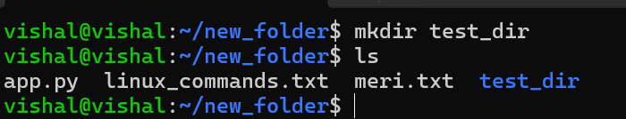
Ans →
Command | Explanation
Mkdir test_dir | A new folder named test_dir will be created in your current location.

Inside test_dir, create an empty file called example.txt.
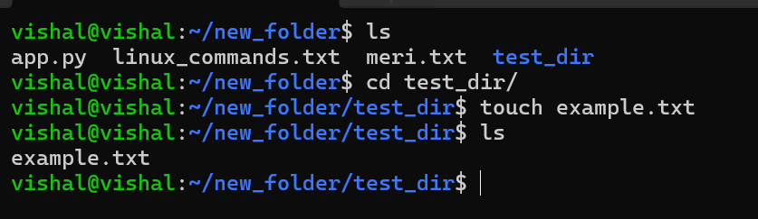
Ans → Command- for create a empty file in test_dir using this commands
Command | explanation
ls | Lists files and directories in the current location
cd test_dir | Changes the current directory (folder)
touch example.txt | Creates a new empty file named example.txt in the current directory.
Rename example.txt to renamed_example.txt using mv
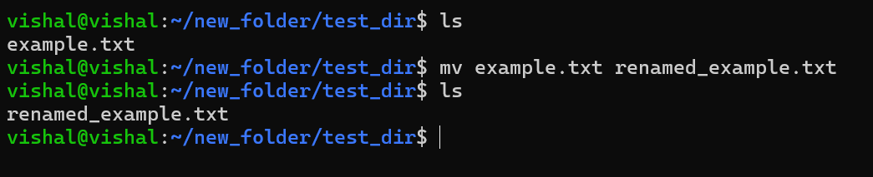

Command | explanation
mv example.txt renamed_example.txt | Renames the file example.txt to renamed_example.txt.

2 Viewing File Contents
Use cat to display the contents of /etc/passwd.
Here is the contents of /etc/passwd file using cat command
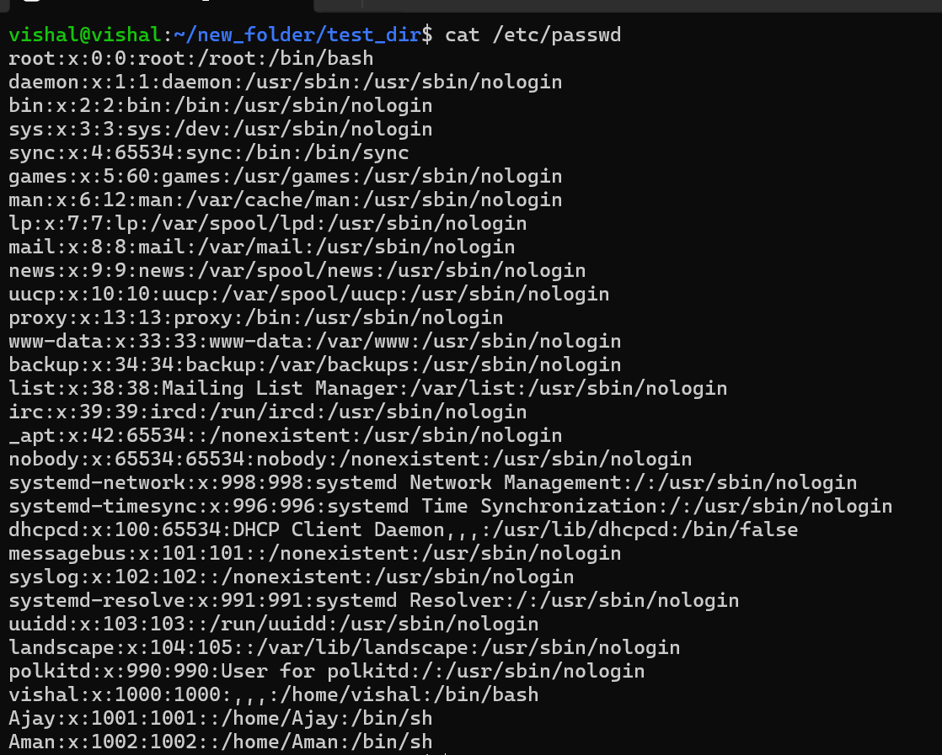
Display only the first 5 lines of /etc/passwd using head.
Using this command → head -n 5 filename (/etc/passwd)
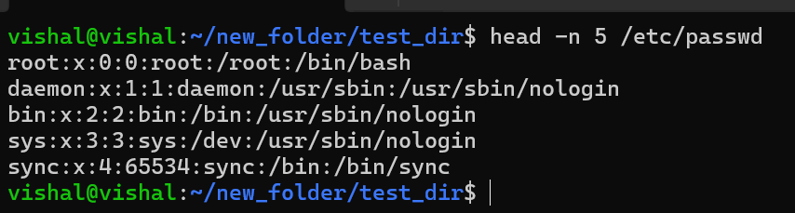
Display only the last 5 lines of /etc/passwd using tail.
Using this command → tail -n 5 filename (/etc/passwd)
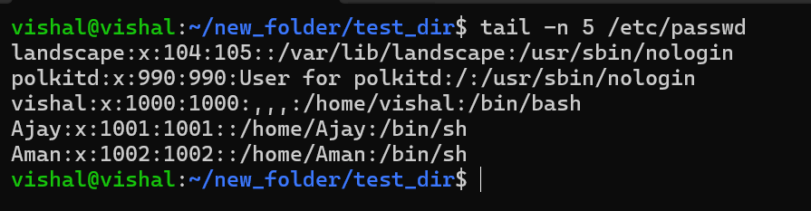
3.Searching for Patterns
Use grep to find all lines containing the word "root" in /etc/passwd.
Using this command → grep root /etc/passwd
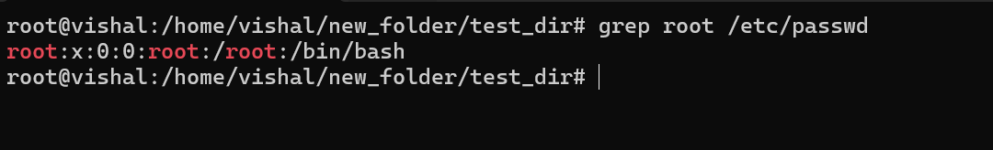4. Zipping and Unzipping
Compress the test_dir directory into a file named test_dir.zip using zip.
Using this command → zip test_dir.zip test_dir
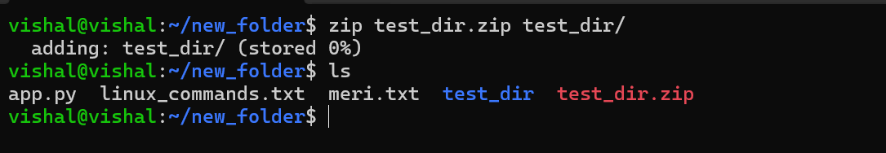
Unzip test_dir.zip into a new directory named unzipped_dir.
Using this command → unzip test_dir.zip -d /home/vishal/unzipped_dir
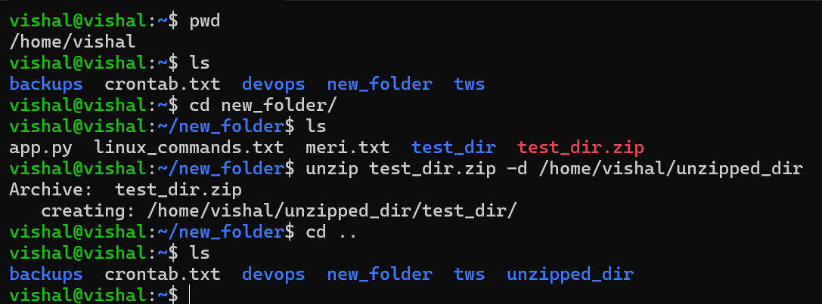
5. Downloading Files
Use wget to download a file from a URL (e.g., https://example.com/sample.txt).
Using this command →
wget https://raw.githubusercontent.com/vishalBagdi/my-static-website/refs/heads/mai n/.github/workflows/deploy.yml
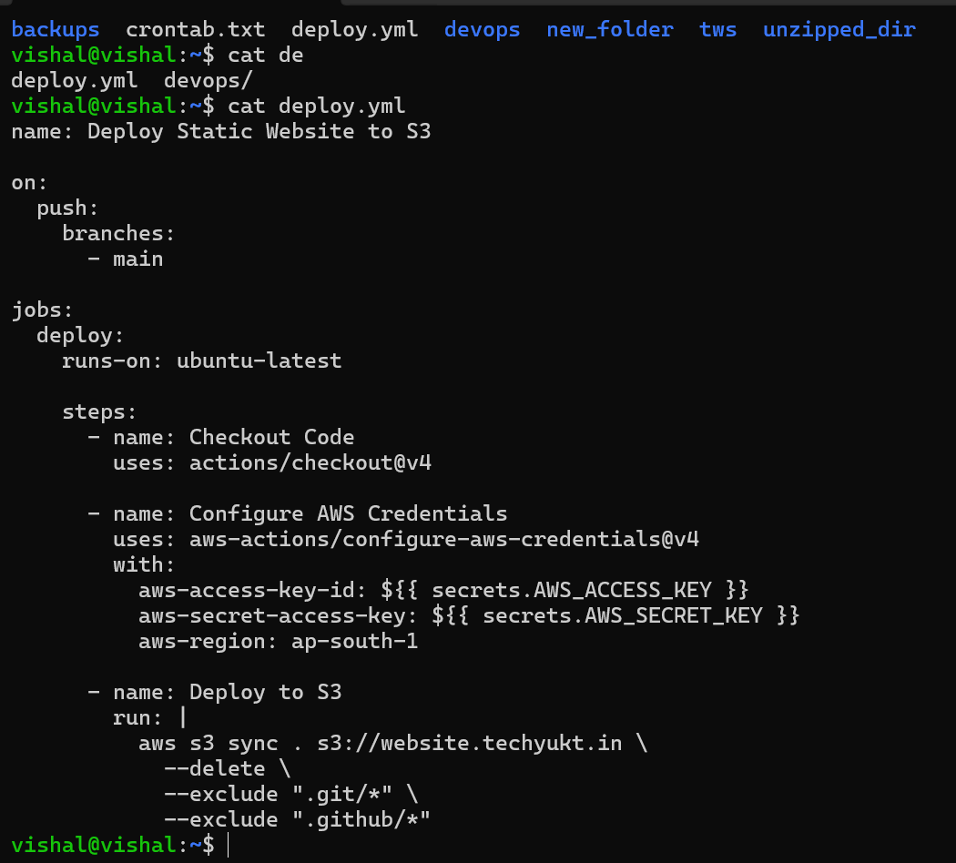

6. Changing Permissions
Create a file named secure.txt and change its permissions to read-only for everyone using chmod.
Using command for permission to read-only is → chmod 444 secure.txt
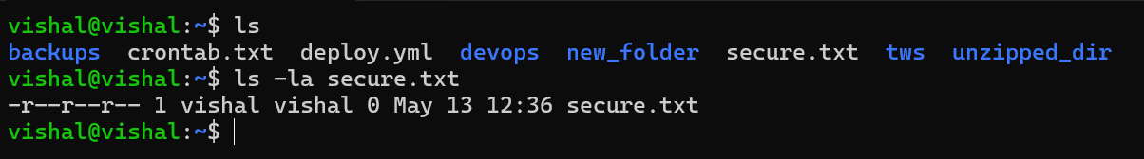

7. Working with Environment Variables
Use export to set a new environment variable called MY_VAR with the value "Hello, Linux!".

Using this command → export MY_VAR= “Hello Linux!”

